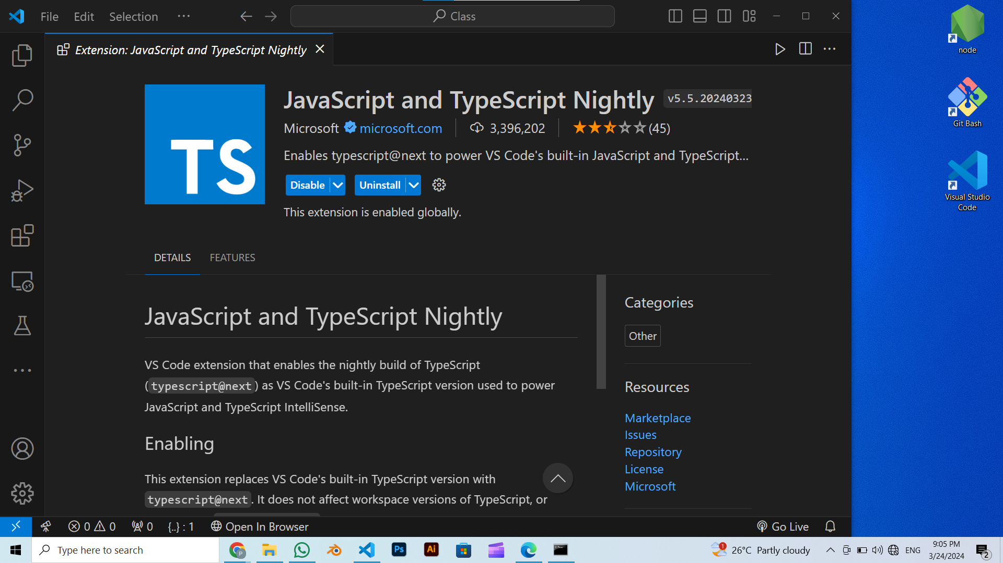Question No.1: Install [Node.js](https://nodejs.org/en/), [TypeScript](https://www.typescriptlang.org/download) and [VS Code](https://code.visualstudio.com/) on your computer.

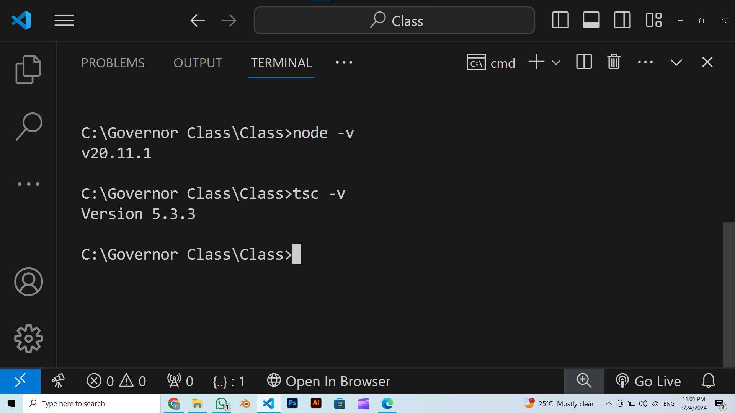

Typescript version

Node.js version